**____________________’s**

**Meteorology Notebook**

**VISIT WITH YOUR FAMILY!**

Explore water and climate science with fun, hands-on exhibits!

From March – October, enjoy the outdoor River Campus with a simulated river and nature playground.

**ADMISSION/LOCATION**

Free

11818 W. Joplin Road (off Chinden Blvd.) Boise, ID 83714

(p) 208.608.7300

**boisewatershed.org**

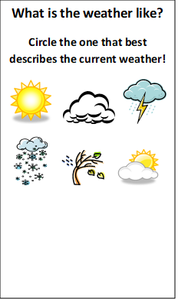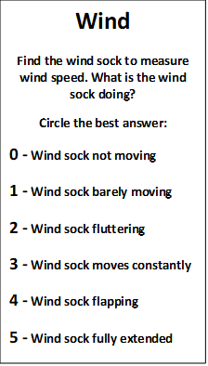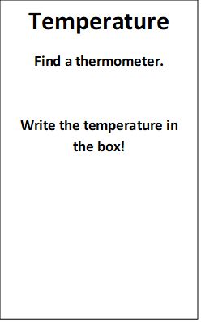

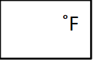

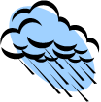

**Label the Seasons**

Average Temperature (°F) in the Treasure Valley



Seasons

Seasons